
Working Principle:
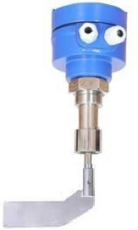
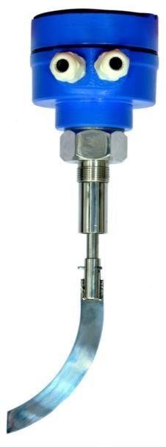
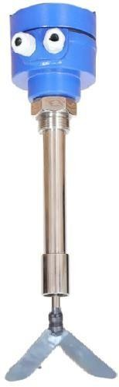
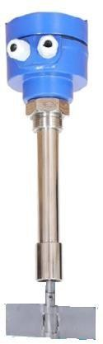
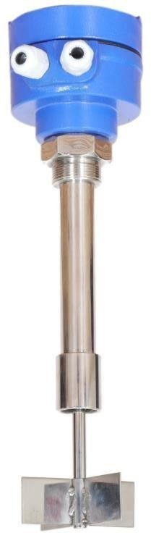
Rotating Paddle Level switch consists electro-mechanical assembly with Geared A.C. Motor, which drives a connected paddle wheel through a special clutch mechanism. The absence of material allows motor to rotate the paddle uninterrupted. When the unit senses the material via the restricted rotation of the paddle, the reversing torque actuates the internal micro-switches fitted in the Housing and
Alarms the unit, to give corresponding switching output signal.

Applications:
Pallets, Powder, Cement, Ash, Material Handling, Argo, Rice, Husk, Food grains, Chemical industries. Dry bulk material applications, powders in hoppers, silo, bins. Compatible with many bulk solids, powders, pelletized and granular applications.

Features:
Simple but reliable switch for level Detection.
Specially designed motor, which does not burn under blocked rotor condition. Specially designed PTFE seal to prevent ingress of dust particles and moisture into main enclosure.
Suitable for Top/side Mounting. Also available in Rope extensions

Technical Specifications

Medium specific gravity: min. 0.07 kg / 𝑚3 and above.

Model: Enclosure:

Cable Entry:
RPLS-600S
IP68 Weather proof, Cast Al, powder coated.
2 X PG 16

Mounting: Screwed – 1 ½” BSP SS (standard) Ambient temperature: 0 ° C to +120° C Std.
Mains Voltage: 24 V DC or 110 V AC 230V AC @ 50 Hz. (Specify)
Power consumption: 4 VA, Motor: 1 RPM CW
Output: 1 C/O contacts rated @ 10 Amps (NO-C-NC) Status display: 5 MM Green LED for Normal Running condition. Sense Probe: SS, 12 MM Dia.
Probe Length: 200 MM (additional Extension available on request.)Paddle: L/J /Cizer/2/3/4 Vane ( Specify)
Working Temperature: 120°C Max.
(Optional High temp. models up to 350°C on Request)

Mechanical Drawing: L Type Fan
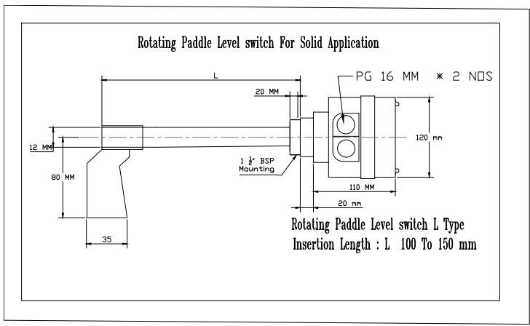

Mechanical Drawing: Cizer Type Fan
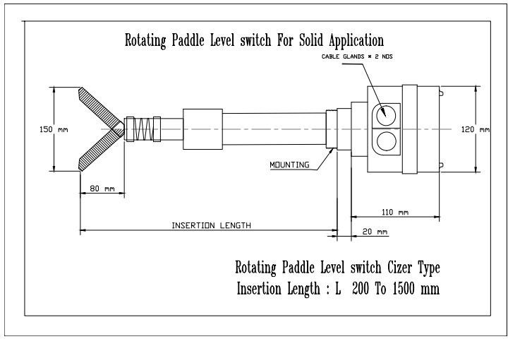

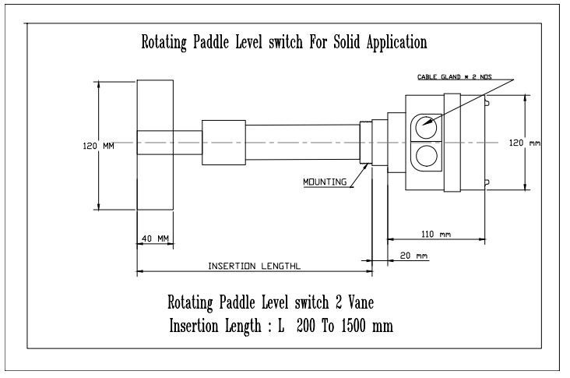
Mechanical Drawing: 2 Vane Type Fan

Mechanical Drawing: 4 Vane Type Fan
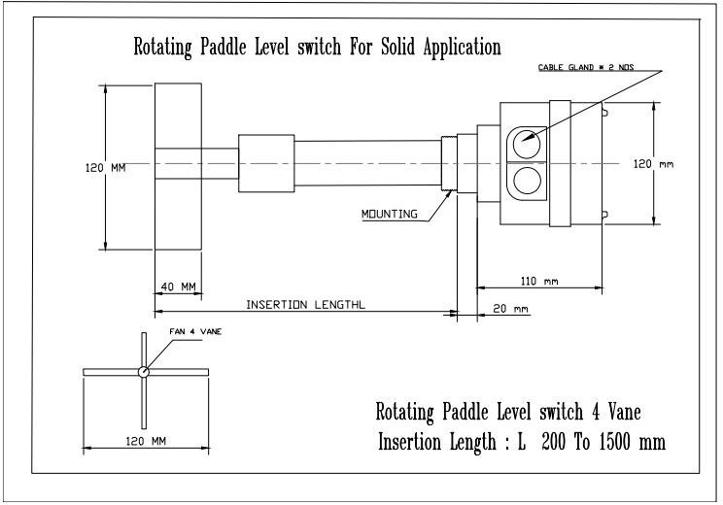

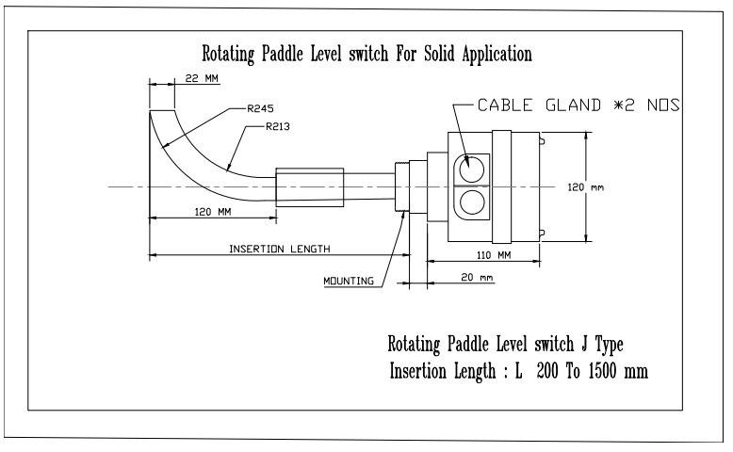
Mechanical Drawing: J Type Fan

INFORMATION REQUIRED Before Purchase
- Process Parameters: Temperature, pressure,
- Requested mounting: Side/Tope?
- Application media: Size of lumps, free flowing or specify?
- Specific. Gravity.
- Supply Voltage, Probe length, Mounting etc.

Manufactured By:

Levtron Instruments Pvt Ltd.
Office No 2, 1st floor, plot no 6, Pandhari Industrial estate, Shivane. Pune 411023, Contact: 09579430012 / 9730042725 E-mail: sales@levtron.in Website : www.Levtron.in

